Solar Concentrator Training System

EcoSCTS - 2.2

**EXPERIMENT MANUAL**

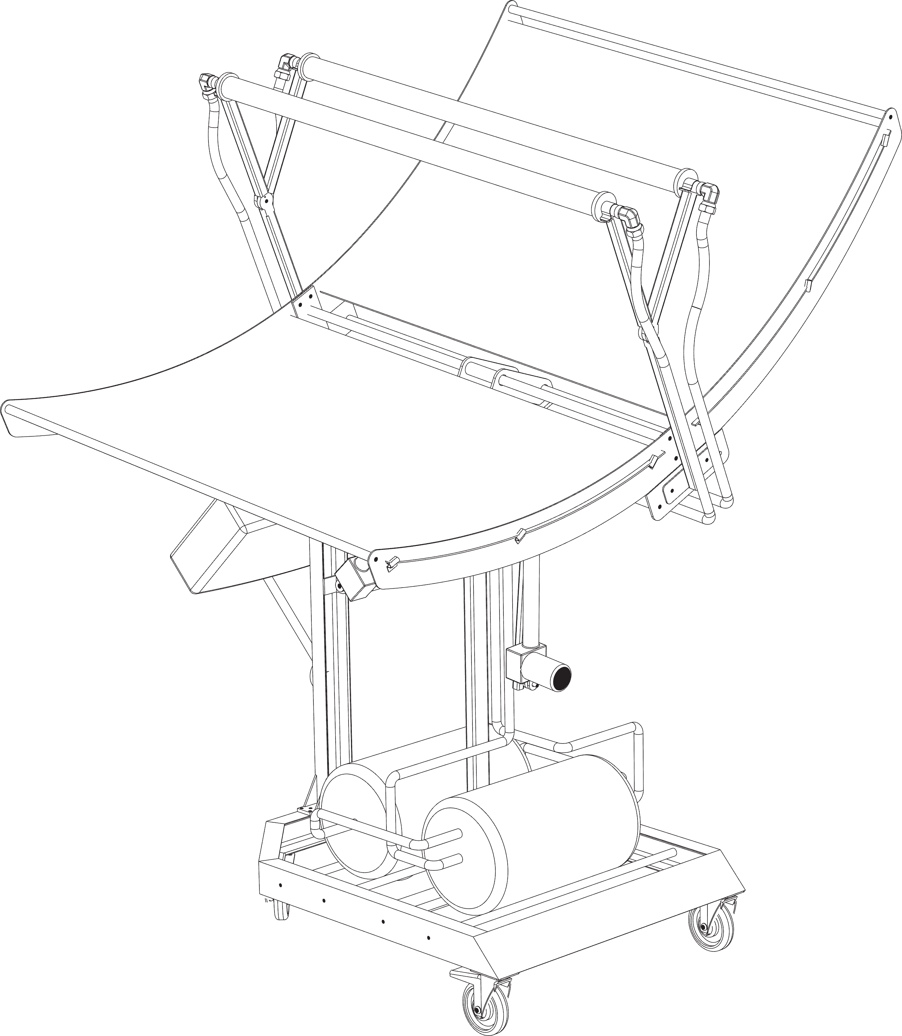

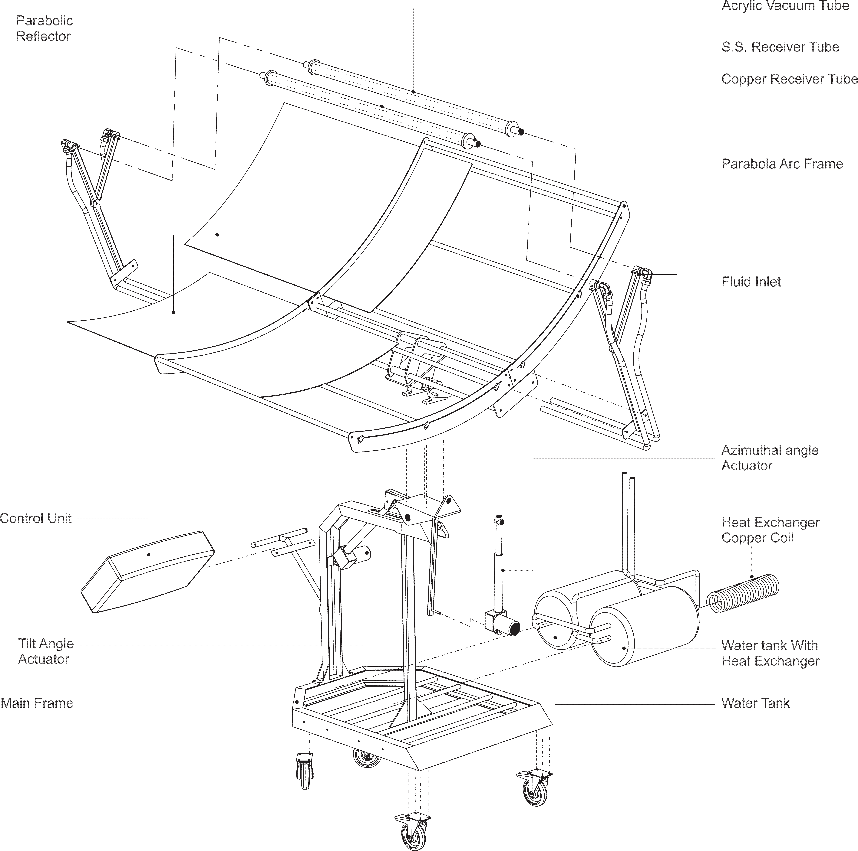

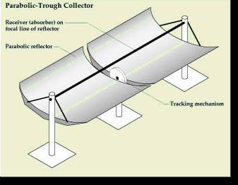

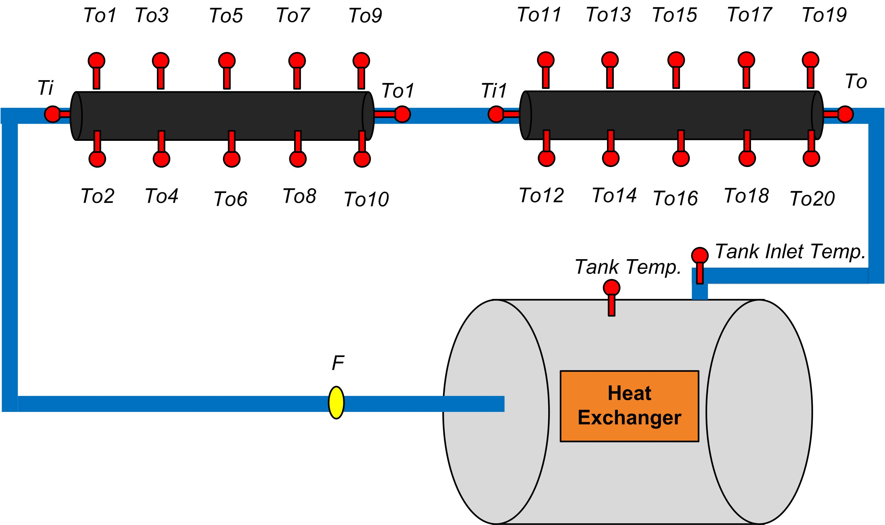

Foreword

The contents of this manual are considered proprietary and confidential to Ecosense Sustainable Solutions Pvt. Ltd. and should not be reproduced without prior written permission from us. Nothing contained in this document is intended to extend any promise, warranty or representation, expressed or implied regarding our products described herein. Any such warranties or other terms and conditions of sale of products shall be in accordance with the standard terms and conditions of sale of such products, which are available upon request.

This manual contains instructions and technical data to cover all routine experiments, set up and operations tasks that can be conducted only by operation and maintenance staff. Major overhauls are outside the scope of this manual and should be referred to the authorized Ecosense Sustainable Solutions Pvt. Ltd. service department.

The design specification of this machine is proprietary holding of Ecosense Sustainable Solutions Pvt. Ltd. and we reserves the right to make changes and improvements to products without notice and without incurring any obligation to make such changes or add such improvements to products sold previou

### Parabolic Trough Technology

Parabolic trough type solar concentrator systems work on the concept of capturing solar energy to heat fluids that can be further used in many ways; one common usage is to pipe it to a heat engine which uses heat energy to drive machinery or to generate electricity.

A parabolic trough type solar concentrator system consists of a set of parabolic shaped ribs which hold a sheet of acrylic glass as a reflective surface for concentrating the solar rays to a focal line, where the receiver tube is placed for absorbing the solar radiation. This concentration of solar energy heats the fluid in the receiver tube. The fluid is then moved to the heat exchanger where the heat exchanger transfers the thermal energy to another medium for industrial heating, power generation or domestic heating purpose

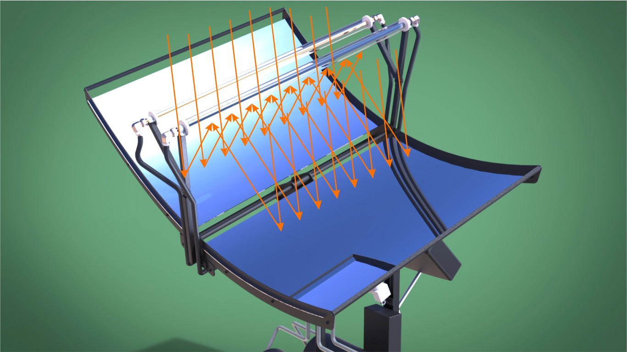



Fig. 2: Geometrical Representation of a Parabola



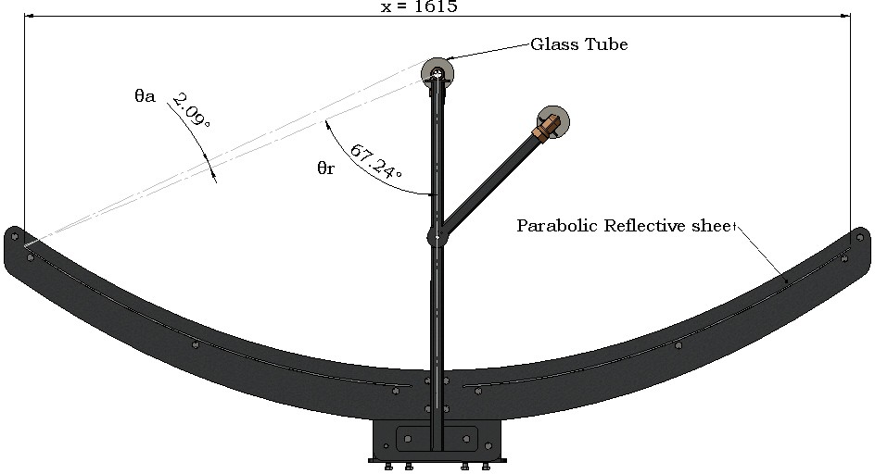

### Applications of Parabolic Trough Type Solar Concentrator System

A parabolic trough type solar concentrator system has several applications across industries. The Solar Concentrator System with Dual Axis enables the user to gain an insight into the concepts of concentrating solar power and parabolic trough collector systems which is the core of all the under mentioned applications:

* Domestic water heating
* Water pre-heating for steam turbine power generation and other industrial uses
* Space heating and thermal energy storage
* Heat source for absorption and adsorption systems
* Super heated steam generation for solar thermal power plants

### Parabolic Trough Type Solar Concentrator System

The performance of an actual parabolic trough type solar concentrator system is very factor based and depends heavily on source elements like the unit of solar insolation hitting the parabolic trough surface and design elements like the solar tracking mode.

The Solar Concentrator Training System at Ecosense is replete with features and functions that have been consolidated after continuous study of the machine’s usage pattern and user feedback. The latest version of the Solar Concentrator Training System has features like dual axis solar tracking, flexibility to use multiple receiver tubes and working fluids – Etc. That expands the scope of research under parabolic trough type solar concentrator systems. Designed indigenously at our research lab it gives hands-on experience of working on a real life prototype of parabolic trough type solar concentrator system. It allows users to evaluate performance of concentrator systems under different atmospheric and material conditions.

Introduction

The new Solar Concentrator Training System with Dual Axis is designed to provide East- West and North-South sun tracking, thus expanding the scope of research under parabolic trough type solar concentrator systems while increasing the rate of accuracy.

This training system has several highlighting features such as the flexibility to use multiple receiver tubes and working fluids, direct and indirect heating, temperature observation

at multiple locations, dual axis tracking etc. The system enables experimentation and research in heat transfer concepts thereby deriving the system performance parameters and overall efficiency

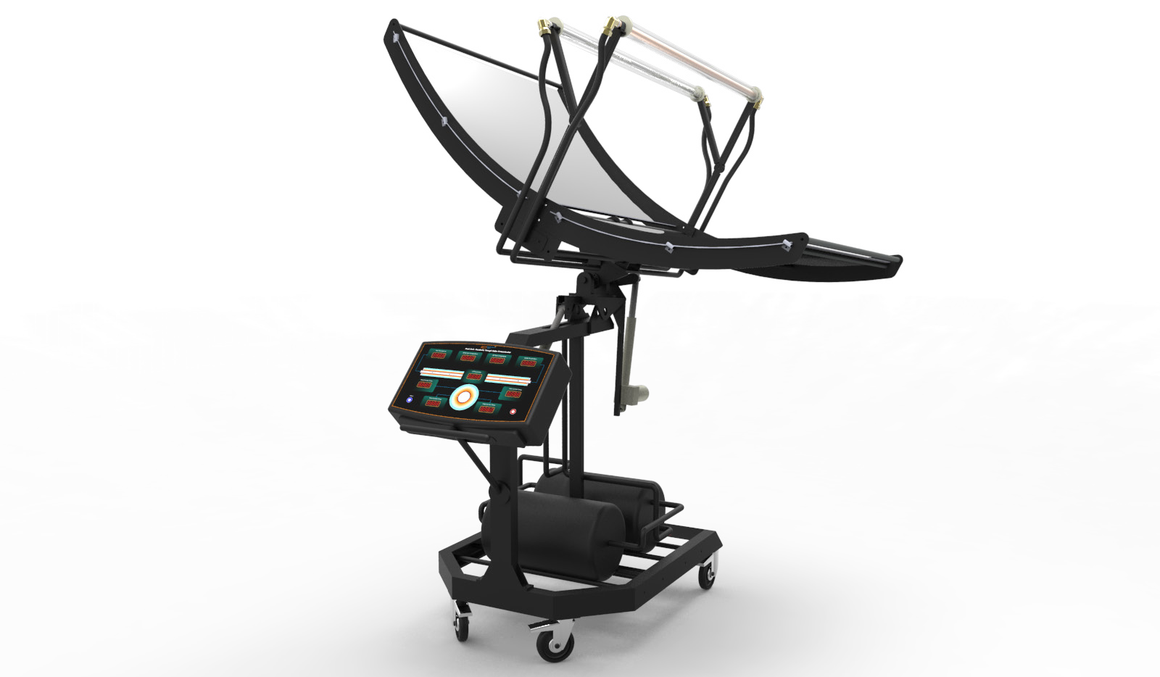 Fig. 3: Dual Axis Solar Concentrator System

### Main Components

##### Parabolic Reflector

Parabolic reflector is the acrylic mirror that lies on the parabolic ribs which move from east to west and north to south with the help of sun tracker. This reflects all the radiation to the focal line.

##### Tracker unit with two actuators

It is the device which rotates the parabolic ribs from east- west direction (Azimuthal) and north- south direction (Tilt). It works on LDR Based Solar Tracking sensors

##### Receiver Tubes

The product contains two types of receiver tubes, stainless steel (SS) and Copper with a selective coating of black nickel. This arrangement is placed at the focal line of the parabolic trough. The black coating increases the absorption of tubes.

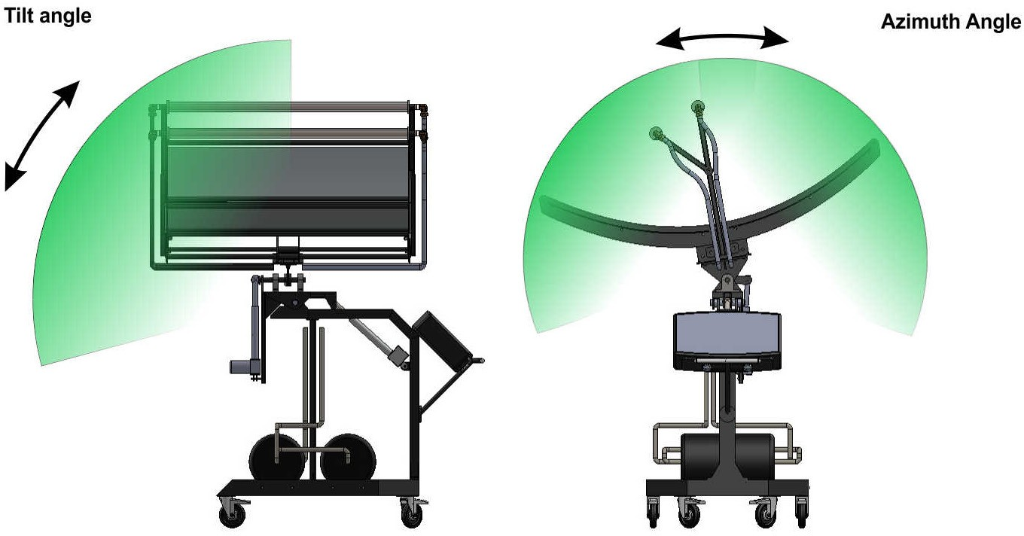

Fig. 4: Tilt Angle and Azimuthal Angle of the sun tracker

Sub Components

* Storage tanks of water (with heat exchanger and without heat exchanger)
* Pumping unit
* Measurement unit
* Additional meters
* Insulation jackets for storage tanks
* 2 pumps, one for water and another for oil
* Control unit (includes T-sensors, flow meter, pump-regulator)
* Radiation meter and anemometer

Specifications

|  |  |  |
| --- | --- | --- |
| **S.No.** | **Components** | **Specifications** |
| **1** | **Heat generating unit with tracking system** |  |
|  | **Parabolic reflector** |  |
| * Length | 4 ft |
| * Arc length (perimeter) | 5.5 ft |
| * Depth | 0.68 ft |
| * Focal length | 1.99ft |
| * Material | Acrylic mirror |
|  | **Sun tracker** | Double Axis |
| Operating voltage | 24V |
| Azimuth Angle | -55 to +55 |
| Tilt Angle | 00 to 45 |
|  | **Absorber tube** |  |
| * Length | 4 ft |
| * Outer diameter | 1 inch |
| * Absorber material | Copper and SS |
| * Piping material | Galvanized Iron and copper |
|  | **Absorber tube** |  |
| * Length | 4 ft |
| * Outer diameter | 1 inch |
| * Absorber material | Copper and SS |
| * Piping material | Galvanized Iron and copper |

|  |  |  |
| --- | --- | --- |
| **2** | **Storage and pumping unit** |  |
|  | **Storage tank**   * Capacity * Material * Insulation used * Working fluid | 2 (one with Heat exchanger and other without heat exchanger)  56 ltr SS  Glass wool with Rexene cover  Water and heat transfer oil |
|  | **Pump (for water)**   * Power rating * Head   **Pump (for oil)**   * Power rating * Head | 1 HP 15m  1.0 HP 26m |
|  | **Meters**   * Temperature meters * Flow meter * Radiation meter * Anemometer | 0-1990C/RTD type  1.5-20LPM/small turbine type 0-1999 W/m2  0.25-45 m/s |
| **3** | **Accessories** |  |
|  | * Experimental manual * Product manual * Tools for piping and connections * Oil | Heat transfer oil (10 litre) |

Contents

Important Parameters of a Parabolic Trough Heating System 08

Equations and Calculations 09

Experimental Set-up 17

Specification 18

Tracking Unit 20

Experiment 1 21

Experiment 2 27

Experiment 3 33

Experiment 4 39

Experiment 5 45

Experiment 6 51

Experiment 7 57

Nomenclature 63

# Important Parameters of a Parabolic Trough Heating System

The performance of a parabolic trough system depends upon different design and atmospheric parameters. The meaning and importance of some of the most dominating parameters are described below.

Overall Heat loss coefficient (UL):

All the heat that is received by the receiver tube does not result into useful energy. Some of the heat gets lost to the surroundings. The amount of heat loss depends upon the convective, conductive and radiation heat loss coefficients.

Estimation of heat loss coefficient of the system is important for its performance evaluation. A higher value of heat loss coefficient indicates lower heat resistance and hence lower efficiency.

Among all heat loss parameters, the top loss contributes the most in the overall heat loss. The top heat loss coefficient is a function of various parameters which include the temperature of the receiver tube, ambient temperature, glass tube temperature, wind speed and emissivity of the receiver tube.

Heat Removal Factor (FR):

Heat removal factor represents the ratio of the actual useful energy gain to the useful energy gain if the entire receiver were at the fluid inlet temperature. It depends upon the factors like inlet and outlet fluid temperature, the ambient temperature, area of the tube etc. For an efficient system a higher value of heat removal factor is a must.

Efficiency (η):

Efficiency is the most important factor for a system. This factor determines the system’s output. For a parabolic trough system the efficiency is defined as the ratio of the useful energy delivered to the energy incident on the aperture of trough.

Equations and Calculations

1. Heat Loss coefficient (UL)

UL is the overall heat transfer coefficient from the receiver tube. This is an important and complex parameter which tells us the heat loss per unit area per unit temperature

difference from the receiver tube. In this case, UL will be expressed by two terms hr and hw

By multiplying these factors ( hw and hr ) with tube surface area and temperature difference between receiver tube and glass tube temperature, we will get the total heat loss from the receiver tube to glass tube.

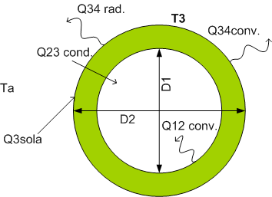

solar

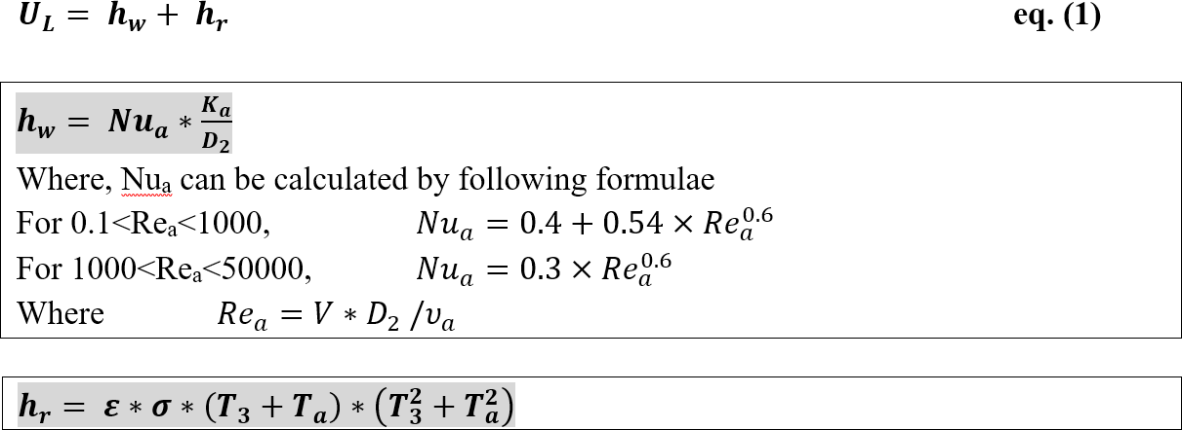

Where,

D2 : Outer diameter of receiver tube(

hw : Convective heat transfer coefficient T3 : Surface temperature of receiver tube ε3 : Emissivity of Selective coating 3

Ta : Ambient temperature

σ : Stefan Boltzmann constant

1. F factors of a receiver tube (F/, FR, )

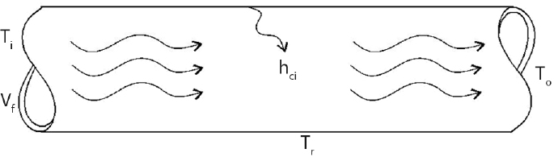

## Collector efficiency factor (F /) :

Collector efficiency factor is constant for any collector design and fluid flow rate. This represents the ratio of actual useful energy gain to the useful energy gain that would result if the receiver tube surface temperature had been at the fluid temperature.

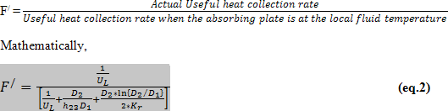

## h23 calculation :

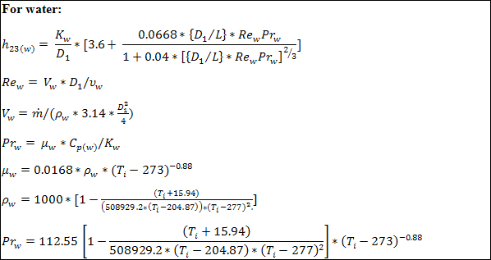

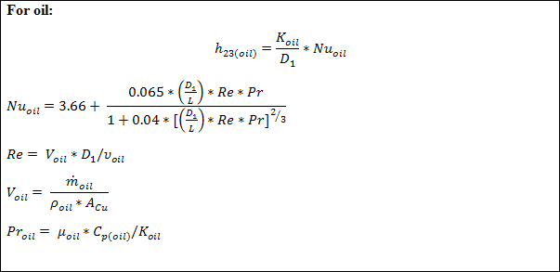

## Heat Removal Factor (FR) :

Heat removal factor is constant for any collector design and fluid flow rate. This represents the ratio of actual useful energy gain to the useful energy gain that would result if the receiver tube surface temperature had been at the fluid inlet temperature.

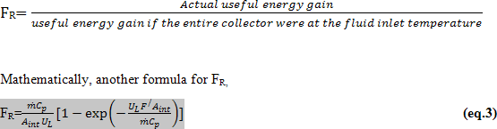

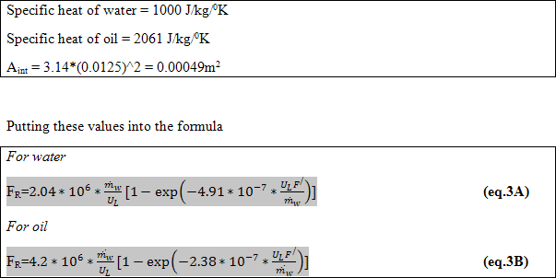

1. Thermal Efficiency of the collector (η)

It is the ratio of the useful heat gain to the total input solar energy Mathematically,

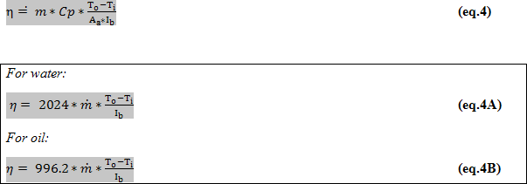

1. Heat Loss in Piping

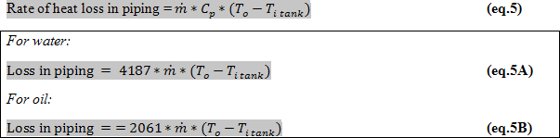

1. Heat Loss in Storage Tank

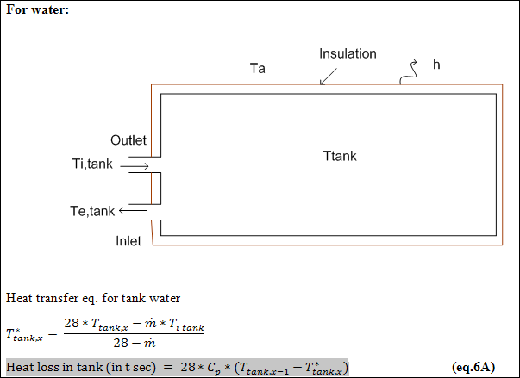

Here,

T1 is the temperature of water after mixing hot water Titank,n is tank inlet temperature at nth observation

Ttank,n is the tank temperature at nth observation

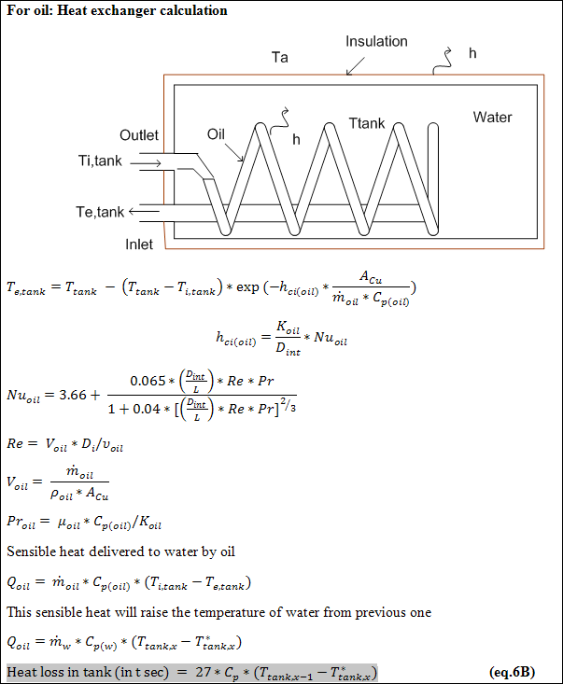

Here,

Qoil,n Heat delivered by heat exchanger in nth observation Titank,n Tank inlet temperature at nth observation

Tetank,n Tank outlet or receiver inlet temperature at nth observation Dint Internal diameter of heat exchanger pipe

L Length of heat exchanger pipe

# Experimental Set-up

## Different components of parabolic trough system are connected to each other in following manner :

There are two types of parameters viz. weather parameters (radiation and wind speed) and user defined parameters (flow rate, insulation thickness and inlet water

temperature). As the weather parameters cannot be controlled, the experiment will have to be performed in parts (i.e. at different time of the day). During a part of experiment, weather parameters should remain unchanged but it will change in other parts of the experiment. Therefore, the complete experiment time can be divided in several time slots and in each time slot radiation, ambient temperature and wind speed should be almost same. Fixed parameters will remain the same during the complete experiment.

**Note:** In all the experiments inlet and outlet of the receiver tubes will be connected to the differential pressure transducer which will further connected to the display meter and will give the value of pressure difference of inlet and outlet of receiver tube.

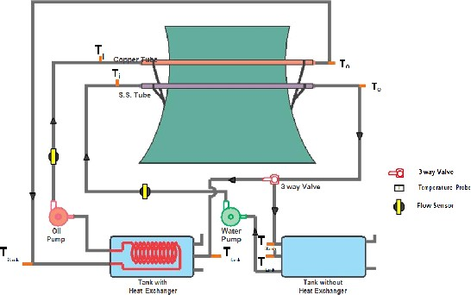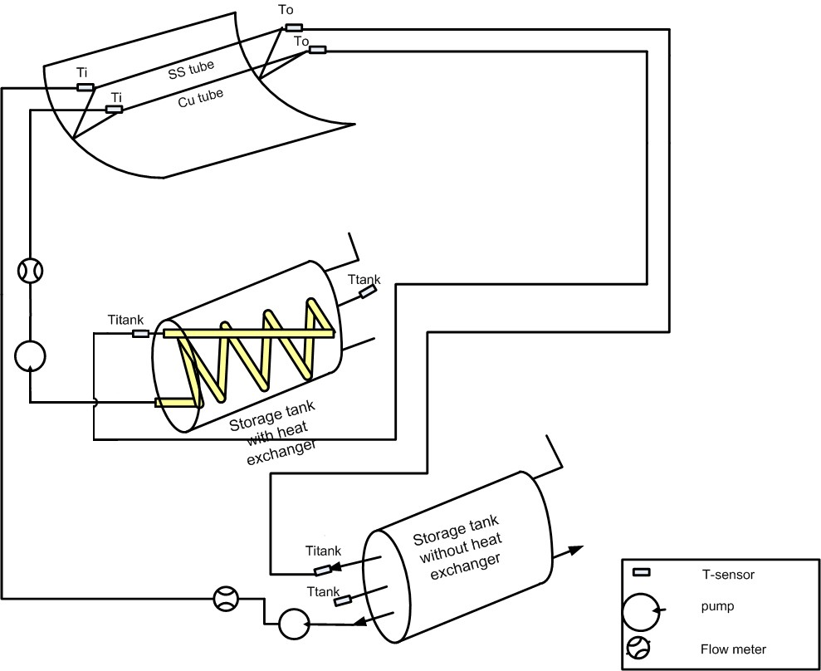

Nomenclature:

hw- Convective heat transfer coefficient between tube and atmosphere

hr Radiative Heat transfer coefficient of radiation

Tr Receiver tube temp.

Ta Ambient temp.

Ka Thermal conductivity of air (0.026W/m/K)

V wind velocity

Nua Nusselt no. of air

Rea Reynolds no. of air

υa Kinematic viscosity of air (1.6*10-5m2/s )

ε Emissivity of receiver tube material (black nickel = 0.66 )

σ Stefan-Boltzman constant (5.67×10−8W m−2 K−4)

UL overall heat transfer coefficient (can be calculated by eq.1)

Dext External diameter of receiver tube (0.025m)

Dint Internal diameter of receiver tube (0.023m)

hci Convective heat transfer coefficient between receiver tube and water

Kr Thermal conductivity of receiver tube material (copper and stainless steel in our system)

L Length of receiver tube (1.2m)

Rew Reynolds no. of water

Prw Prandtl no. of water

υw Kinematic viscosity of water (16.68*10-6m2/s)

Vw Water flow velocity

ρw Density of water

μw Dynamic viscosity of water

Cp(w) Specific heat of water (4.187KJ/Kg/0K)

Kw Thermal conductivity of water (0.6W/m/0K)

Reoil Reynolds no. of oil

Proil Prandtl no. of oil

Voil Oil velocity

υoil Kinematic viscosity of oil (3.0*10- 5m2/s)

ρoil Density of oil (900 Kg/m3)

μoil Dynamic viscosity of oil (0.027Ns/m2)

Cp(oil) Specific heat of oil (2061J/Kg/0K) )

Koil Thermal conductivity of oil (0.165 W/m/0K )

Aint Internal cross sectional area of receiver tube (3.14*(0.0125)2= 0.00049m2)

m Flow rate of fluid (in Kg/sec)

Cp Specific heat of fluid (water or oil)

Aa Aperture area of parabolic reflector (1.695*1.22 = 2.068 m2)

Tracking Unit

The tracking system consist of 4 L.D.R sensors an Adriano (the brain of the tracking system), 10 amp dual channel motor driver board and two actuators for each axis. The 4 L.D.R sensor senses the amount of solar radiation on the top, bottom, left, and right directions. The average values of the radiation in every direction is calculated and

compared in Adriano. The parabolic trough is moved to that direction in which the solar intensity is highest by the help of the actuator.

## Main components and their working

1. **L.D.R sensors**: There are 4 L.D.R sensor to sense the amount of radiation in 4 directions.
2. **Arduino**: It is basically a microcontroller based on Atmega 328. It helps to compare the amount of solar radiation in all 4 directions and gives signals to the motor driver for the operation of actuators
3. **Motor driver (dual channel 10 amps)**: The micro controller output is not sufficient enough to drive a 5 amp rating motor so a driver board is used which amplifies the output of the Arduino and helps to run the motor.
4. **Linear actuator**: It is a dc motor based linear actuator which is used to tilt the parabolic trough.
5. **24 Volts S.M.P.S.**: It is used to power the motor driver board.
6. **9 Volts adapter**: It is used to power the Arduino board.

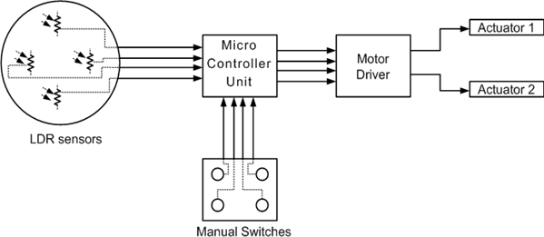

Experiment 1

EcoSCTS 2.2

Objective

Determine the performance (UL, FR, η) of the parabolic trough collector with fixed parameters and (i) Water and (ii) Oil as working fluid.

Theory

At fixed parameters, heat transfer characteristics and heat removal factor will remain the same as there will be no change in the user defined parameters as well as weather parameter.

Experimental Set-up and Procedure

A schematic sketch of the test setup of the constructed parabolic trough concentrator for domestic hot water application is shown in figure. The test setup consists of a solar collector, storage tank of 80-L capacity; control valve or pump regulator are used to regulate the flow rate through the circuit.

The necessary instruments are attached to the apparatus. For performance evaluation of a system, data collection is important, and for the data collection, measuring instrument is needed. The following instruments were used which are inbuilt in control unit.

1. Wind Velocity: Digital anemometer
2. Temperature measurements: Digital Multi-meter with Platinum resistor kit (Digital display)
3. Solar radiation: Digital flux meter
4. Mass flow rate: Turbine type flow meter

This experiment will be completed in two parts, one part with water as working fluid and the other with oil as working fluid.

1. For this, we have to fix the V-clamp such that SS receiver tube will remain at focus of parabolic reflector. Insulation thickness (of tank and pipe) will not change during this experiment.
2. For this, we have to fix the V-clamp such that Cu receiver tube will remain at focus of parabolic reflector. Insulation thickness (of tank and pipe) will not change during this experiment.

Observations

## Set A: Water as working fluid

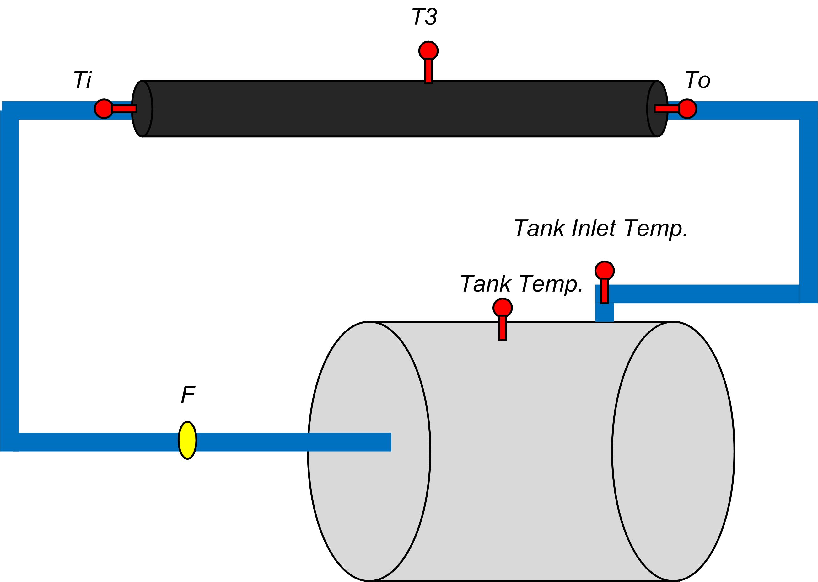

Tank insulation thickness = Pipe insulation thickness =

Supply Voltage =

Supply Current =

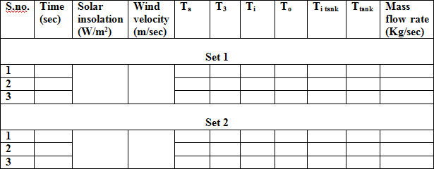

Where:

T3 is surface Temperature

Ti = Receiver Tube inlet temperature

To = Receiver tube outlet temperature

Ta = Ambient Temperature

T tank = Storage Tank Temperature

Ti tank = Tank inlet Temperature.

## Set B: Oil as working fluid

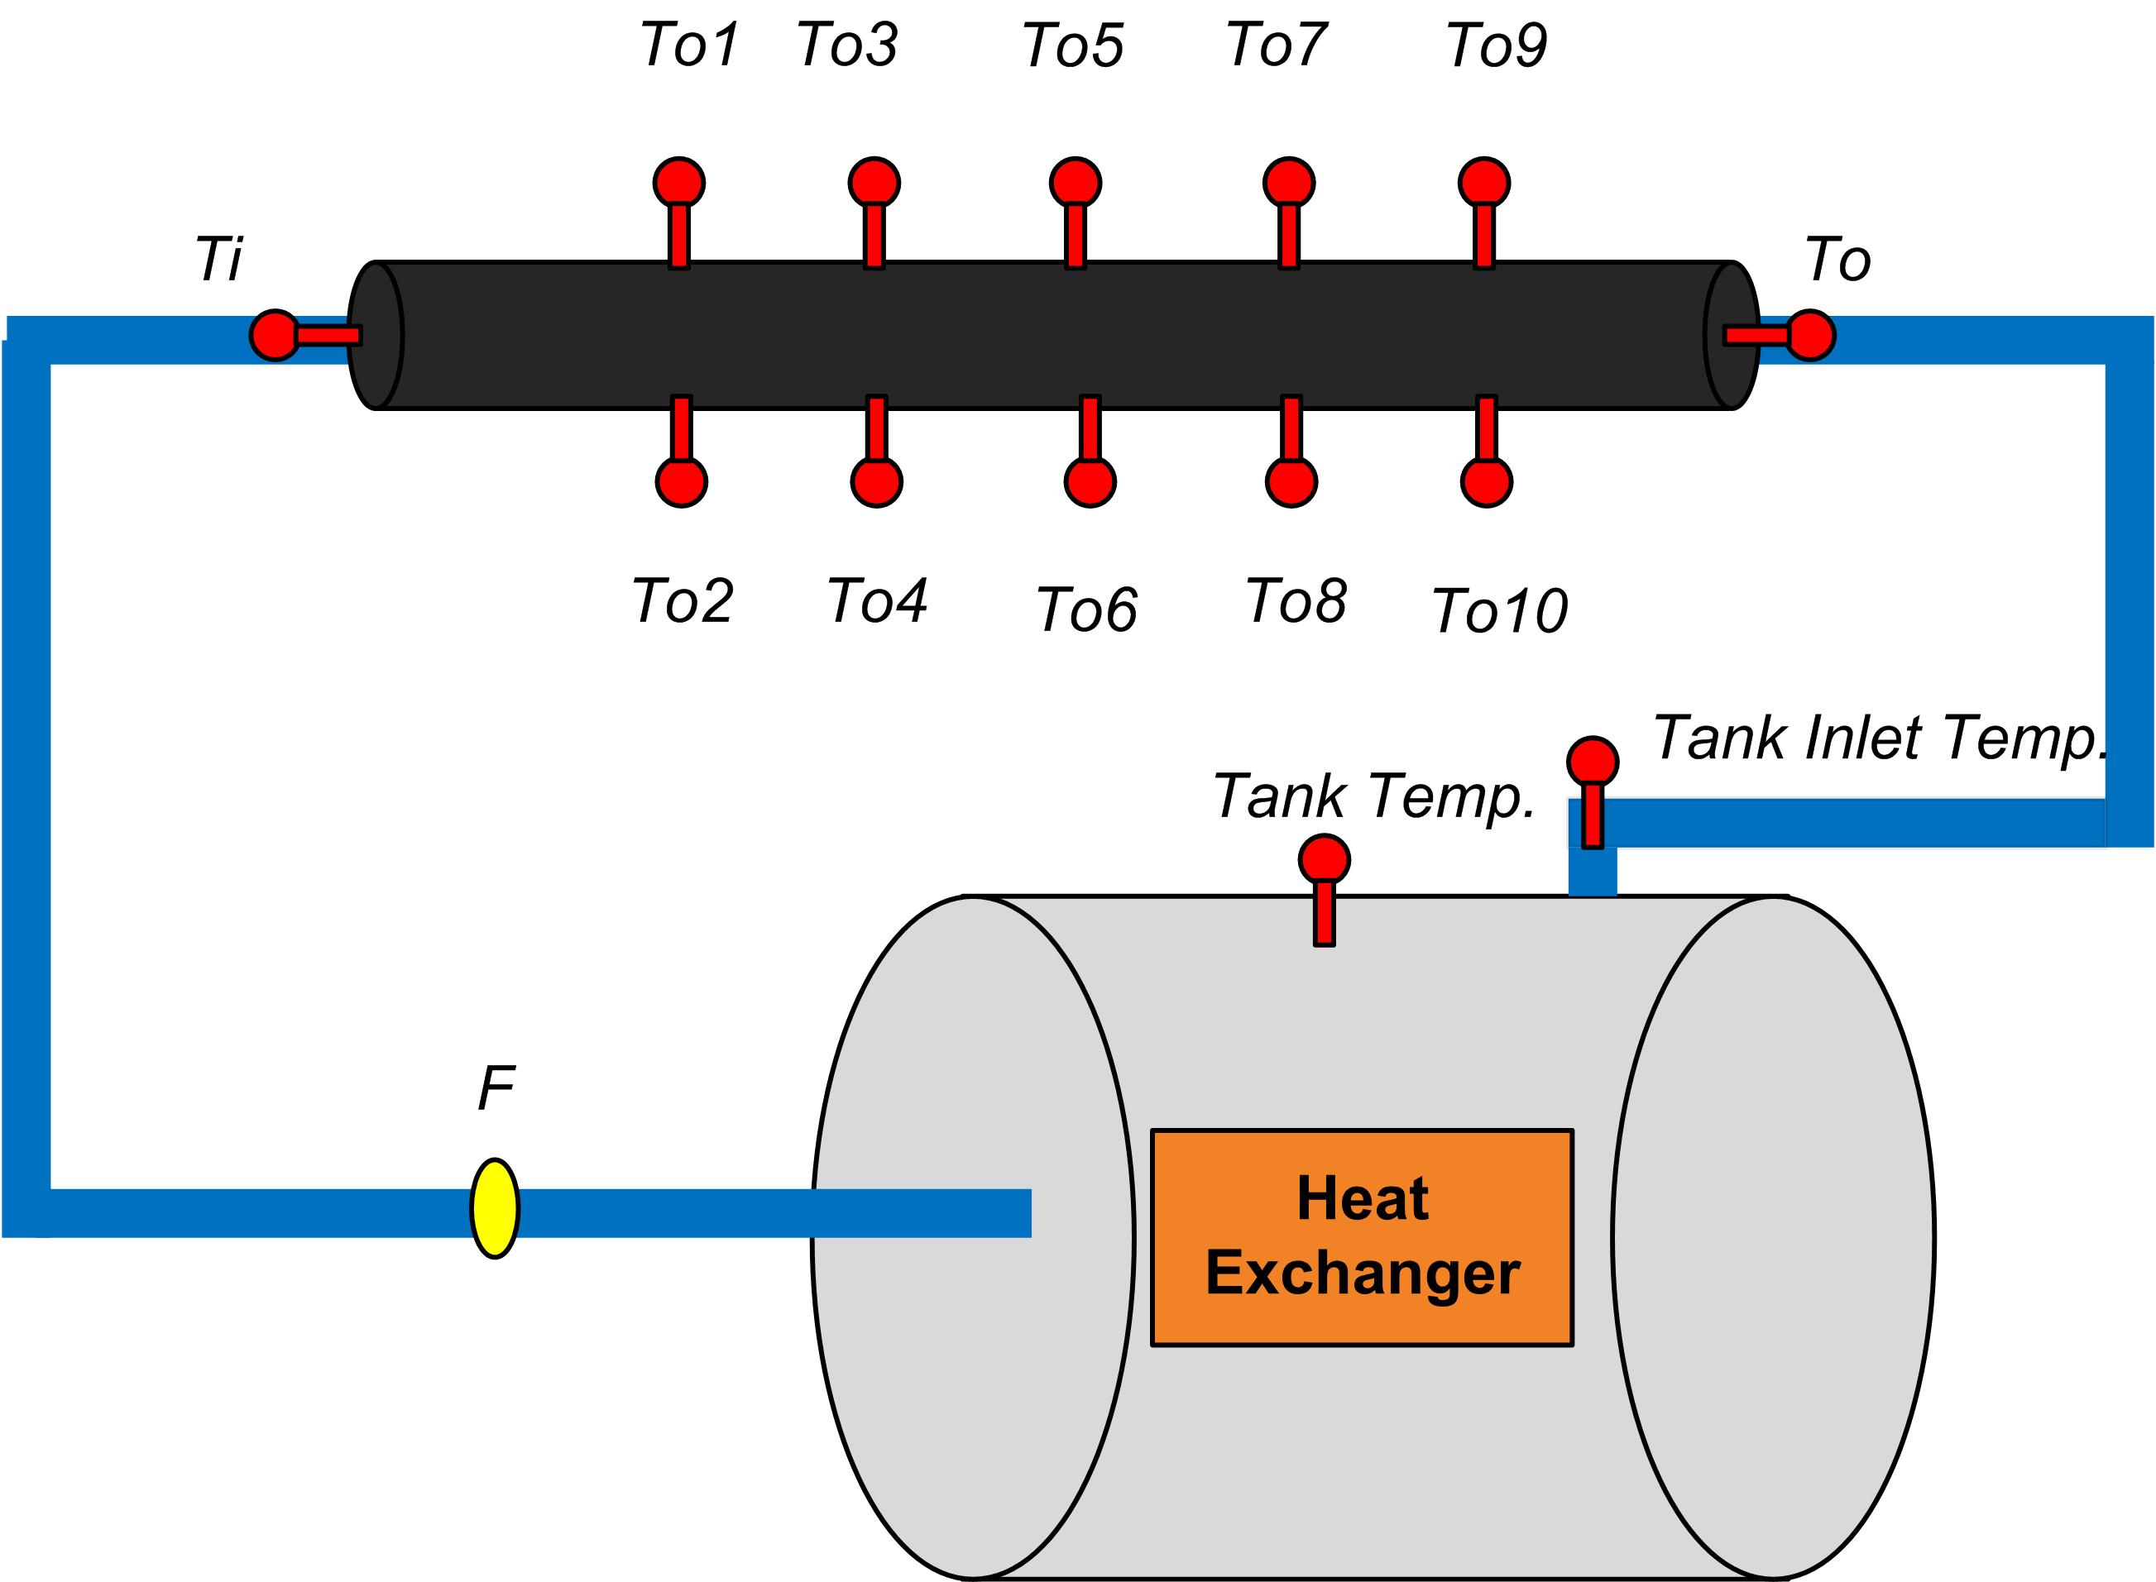

Tank insulation thickness = Pipe insulation thickness =

Supply Voltage =

Supply Current =





Where T3 is Average Receiver Tube Temperature

T3 = (To1 + T02 + T03 +T04 + T05 + T06 + T07 + T08 + T09 + T010)/10

Ti = Receiver Tube Inlet Temperature

TO = Receiver Tube Outlet Temperature

Calculations

Mass flow rate, wind velocity, solar insolation and insulation thickness will remain the same during the calculation of different parameters. If any of weather parameter changes, do the calculation in parts in which all parameters remain constant all the time. Following equations will be used for evaluation of different parameters.

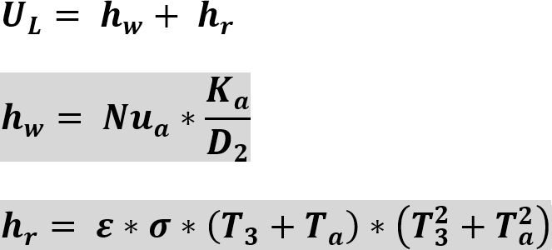

## Water as working fluid

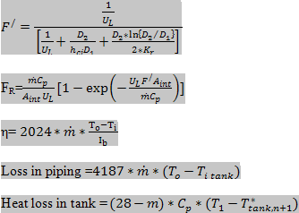

## Oil as working fluid

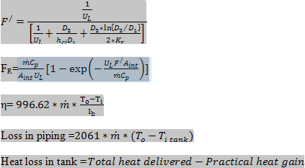

Results

Calculate all performance parameters of this system.

Conclusion

Compare the system with both kind of fluid and make decision which system is performing better.

Experiment 2

EcoSCTS 2.2



Objective

Determine the Performance (UL, FR, η) of the Parabolic Trough collector with varying solar insolation with (i) Water and (ii) Oil as working fluid.

Theory

Increment in solar Insolation will force the temperature of receiver tube to rise thereby affecting the overall heat loss coefficient and heat transfer to fluid. That means a change in solar insolation will affect the efficiency of the system directly by changing the value of heat loss coefficient and tube to fluid transfer coefficient

Experimental Set-up

For this experiment, the user will have to perform one set of the experiment at particular time of the day which will be corresponding to the constant solar radiation value and other sets at the other times of the day so that all sets will be performed at fix radiation values but the radiation value of all sets will be different to each other.

Remaining set-up will remain the same as in experiment no.1

Observations

## Set A: Water as working fluid



Tank insulation thickness = Pipe insulation thickness =

Supply Voltage =

Supply Current =

## Set A: Water as working fluid



Where:

T3 is surface Temperature

Ti = Receiver Tube inlet temperature

To = Receiver tube outlet temperature

Ta = Ambient Temperature

T tank = Storage Tank Temperature

Ti tank = Tank inlet Temperature

## Set B: Oil as working fluid



Tank insulation thickness = Pipe insulation thickness =

Supply Voltage =

Supply Current =





Where T3 is Average Receiver Tube Temperature

T3 = (To1 + T02 + T03 +T04 + T05 + T06 + T07 + T08 + T09 + T010)/10

Ti = Receiver Tube Inlet Temperature

TO = Receiver Tube Outlet Temperature.

Calculations

Mass flow rate, wind velocity, solar insolation and insulation thickness will remain the same during the calculation of different parameters. If any of weather parameter changes, do the calculation in parts in which all parameters remain constant all the time. Following equations will be used for evaluation of different parameters.



## Water as working fluid



## Oil as working fluid



Results

Calculate all performance parameters of this system.

Conclusion

Show the variation in system performance (efficiency and heat loss coefficient) with change in solar insolation for both kind of fluids and receiver tubes.

Experiment 3

EcoSCTS 2.2

Objective

Determine the Performance (UL, FR, η) of the Parabolic Trough collector by varying the flow rate of fluid with (i) Water and (ii) Oil as working fluid.

Theory

Flow rate is the factor which decides the amount of heat utilization from the receiver tube inner surface. If the temperature of the receiver tube is at a particular temperature then amount of heat drawn from the tube will depend on the flow speed. If the flow rate is high then amount of drawn heat will be less and vice versa. But at the same time, high flow rate will be associated with less heat loss from the fluid flow.

Experimental Set-up

For this experiment, the user will have to fix the flow rate of fluid with the help of pump regulator and observe the different parameters at this flow rate this will generate the set-1 of the observation table. But if there is any change in weather parameters then this set will be split into two or more sub sets according to no. of variations in weather parameters. In other words, all the readings will be corresponding to same weather parameters in a sub set but flow readings will be same for all sub sets.

Remaining set-up will remain the same as it was in previous experiments.

Observations

## Set A: Water as working fluid



Tank insulation thickness = Pipe insulation thickness =

## Set A: Water as working fluid

Where:

T3 is surface Temperature

Ti = Receiver Tube inlet temperature

To = Receiver tube outlet temperature

Ta = Ambient Temperature

T tank = Storage Tank Temperature

Ti tank = Tank inlet Temperature

## Set B: Oil as working fluid

## 

Tank insulation thickness = Pipe insulation thickness =

## Set B: Oil as working fluid

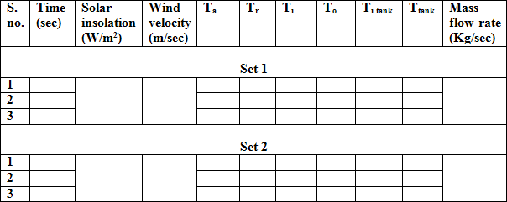



Where T3 is Average Receiver Tube Temperature

T3 = (To1 + T02 + T03 +T04 + T05 + T06 + T07 + T08 + T09 + T010)/10

Ti = Receiver Tube Inlet Temperature

TO = Receiver Tube Outlet Temperatu

Calculations

Mass flow rate, wind velocity, solar insolation and insulation thickness will remain the same during the calculation of different parameters. If any of weather parameter changes, do the calculation in parts in which all parameters remain constant all the time. Calculate all the parameters for each set by keeping mass flow rate constant in a set. Following equations will be used for evaluation of different parameters.

## Water as working fluid

Performance parameters will be evaluated with the help of eq. 1A, 2, 3A, 4A, 5A, B, C, 6A and 7A.

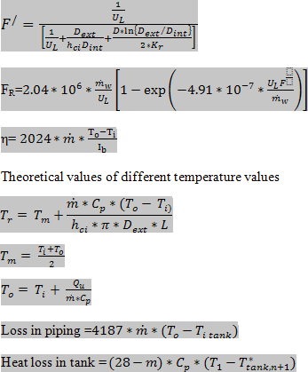

## Oil as working fluid

Performance parameters will be evaluated with the help of eq. 1B, 2, 3B, 4B, 5A, B, C, 6B and 7B.

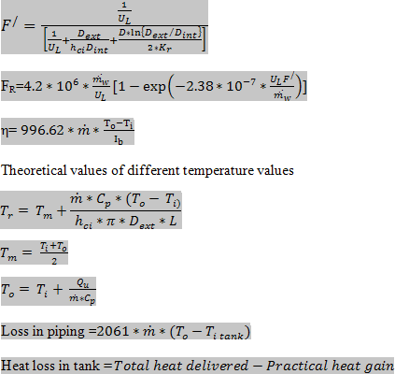

Results

Calculate all performance parameters of this system.

Conclusion

Show the variation in system performance (efficiency and heat loss coefficient) with change in flow rate for both kind of fluids and receiver tube

Experiment 4

EcoSCTS 2.2

Objective

Determine the Performance (UL, FR, η) of the Parabolic Trough collector for different wind speed with (i) Water and (ii) Oil as working fluid.

Theory

Wind speed is responsible for the heat loss through the objects (like receiver tube, piping and storage tank). As the wind speed increases the overall heat loss coefficient also increases. In other words, higher air flow will increase the heat loss from the receiver tube (as receiver tube is at a higher temperature with respect to the ambience).

Experimental Set-up

In this experiment, the user will have to take the readings of one set when the wind speed is almost constant in that time period. In other words, in each set all the weather data has to be constant so that the calculation can be done in an easier way.

Remaining set-up will remain same as it was in previous experiments.

Observations

## For Wind Speed (Set-up 1) =



Tank insulation thickness = Pipe insulation thickness =

## Set A: Water as working fluid

Where:

Tr= is surface Temperature

Ti = Receiver Tube inlet temperature

To = Receiver tube outlet temperature

Ta = Ambient Temperature

T tank = Storage Tank Temperature

Ti tank = Tank inlet Temperature

## Set B: Oil as working fluid



Tank insulation thickness = Pipe insulation thickness =





Where Tr is Average Receiver Tube Temperature

Tr = (To1 + T02 + T03 +T04 + T05 + T06 + T07 + T08 + T09 + T010)/10

Ti = Receiver Tube Inlet Temperature

TO = Receiver Tube Outlet Temperatu

## For Wind Speed (Set-up 2) =

Tank insulation thickness = Pipe insulation thickness =

## Set A: Water as working fluid

Where:

Tr= is surface Temperature

Ti = Receiver Tube inlet temperature

To = Receiver tube outlet temperature

Ta = Ambient Temperature

T tank = Storage Tank Temperature

Ti tank = Tank inlet Temperature

Tank insulation thickness = Pipe insulation thickness =

## Set B: Oil as working fluid



Where Tr is Average Receiver Tube Temperature

Tr = (To1 + T02 + T03 +T04 + T05 + T06 + T07 + T08 + T09 + T010)/10

Ti = Receiver Tube Inlet Temperature

TO = Receiver Tube Outlet Temperatu

Calculations

Mass flow rate, wind velocity, solar insolation and insulation thickness will remain the same during the calculation of different parameters. If any of weather parameter changes, do the calculation in parts in which all parameters remain constant all the time. Calculate all the parameters for each set by keeping mass flow rate constant in a set. Following equations will be used for evaluation of different parameters.

## Water as working fluid

Performance parameters will be evaluated with the help of eq. 1A, 2, 3A, 4A, 5A, B, C, 6A and 7A.



## Oil as working fluid

Performance parameters will be evaluated with the help of eq. 1B, 2, 3B, 4B, 5A, B, C, 6B and 7B.



Results

Calculate all performance parameters of this system.

Conclusion

Show the variation in system performance (efficiency and heat loss coefficient) with change in flow rate for both kind of fluids and receiver tubes.

Experiment 5

EcoSCTS 2.2 Objective

Determine the Performance (UL, FR, η) of the Parabolic Trough collector at different ambient temperature with (i) Water and (ii) Oil as working fluid.

Theory

Ambient temperature is the main factor which affects the losses through the different parts of the system. If the ambient temperature is high then the losses through the receiver tube, storage tank and piping will be less and losses will be higher at lower ambient temperature.

Experimental Set-up

For this experiment, the user will have to perform one set of the experiment at particular time of the day which will be corresponding to the constant ambient temperature value and similarly other sets at the other times of the day so that all sets will be performed at fix ambient temperature values but the temperature value of all sets will be different to each other.

Remaining set-up will remain the same as it was in previous experiments.

Observations

## For Ambient Temperature (Set-up 1) =

Tank insulation thickness = Pipe insulation thickness =



## Set A: Water as working fluid

Where:

Tr= is surface Temperature

Ti = Receiver Tube inlet temperature

To = Receiver tube outlet temperature

Ta = Ambient Temperature

T tank = Storage Tank Temperature

Ti tank = Tank inlet Temperature



Tank insulation thickness = Pipe insulation thickness =

## Set B: Oil as working fluid





Tr = (To1 + T02 + T03 +T04 + T05 + T06 + T07 + T08 + T09 + T010)/10

Ti = Receiver Tube Inlet Temperature

TO = Receiver Tube Outlet Temperatur

## For Ambient Temperature (Set-up 2) =

Tank insulation thickness = Pipe insulation thickness =



## Set A: Water as working fluid

Where:

Tr= is surface Temperature

Ti = Receiver Tube inlet temperature

To = Receiver tube outlet temperature

Ta = Ambient Temperature

T tank = Storage Tank Temperature

Ti tank = Tank inlet Temperature



Tank insulation thickness = Pipe insulation thickness =

## Set B: Oil as working fluid



Tank insulation thickness = Pipe insulation thickness =

## Set B: Oil as working fluid





Tr = (To1 + T02 + T03 +T04 + T05 + T06 + T07 + T08 + T09 + T010)/10

Ti = Receiver Tube Inlet Temperature

TO = Receiver Tube Outlet Temperature.

Calculations

Mass flow rate, wind velocity, solar insolation and insulation thickness will remain the same during the calculation of different parameters. If any of weather parameter changes, do the calculation in parts in which all parameters remain constant all the time. Calculate all the parameters for each set by keeping mass flow rate constant in a set. Following equations will be used for evaluation of different parameters.

## Water as working fluid

Performance parameters will be evaluated with the help of eq. 1A, 2, 3A, 4A, 5A, B, C, 6A and 7A.



## Oil as working fluid

Performance parameters will be evaluated with the help of eq. 1B, 2, 3B, 4B, 5A, B, C, 6B and 7B.



Results

Calculate all performance parameters of this system.

Conclusion

Show the variation in system performance (efficiency and heat loss coefficient) with change in ambient temperature for both kind of fluids and receiver tubes.

Experiment 6



Objective

Determine the Performance (UL, FR, η) of series combination of Parabolic Trough collector with fixed parameter with (i) Water and (ii) Oil as working fluid.

Theory

At fixed parameters, heat transfer characteristics and heat removal factor will remain the same as there will be no change in the user defined parameters as well as weather parameter. In this experiment we are connecting two trough collector in series combination.

Experimental Set-up

A schematic sketch of the test setup of the constructed parabolic trough concentrator for domestic hot water application is shown in figure. The test setup consists of a solar collector, storage tank of 80-L capacity; control valve or pump regulator are used to regulate the flow rate through the circuit.

In this experiment we connecting two parabolas in series as shown in figure.

The necessary instruments are attached to the apparatus. For performance evaluation of a system, data collection is important, and for the data collection, measuring instrument is needed. The following instruments were used which are inbuilt in control unit.

1. Wind Velocity: Digital anemometer
2. Temperature measurements: Digital Multi-meter with Platinum resistor kit (Digital display)
3. Solar radiation: Digital flux meter
4. Mass flow rate: Turbine type flow meter

This experiment will be completed in two parts, one part with water as working fluid and the other with oil as working fluid.

1. For this, we have to fix the V-clamp such that SS receiver tube will remain at focus of parabolic reflector. Insulation thickness (of tank and pipe) will not change during this experiment.
2. For this, we have to fix the V-clamp such that Cu receiver tube will remain at focus of parabolic reflector. Insulation thickness (of tank and pipe) will not change during this experiment.

Observations

## Set A: Water as working fluid

Tank insulation thickness = Pipe insulation thickness =

Supply Voltage =

Supply Current =

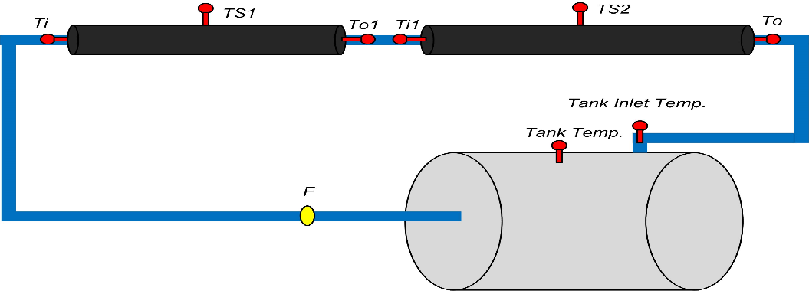

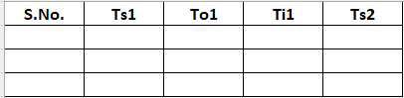

**Where T3 is average temperature of Receiver Tube. As shown in Figure.**

**In case of Water as Heat Transfer Fuild**

**T3 = (Ts1 + Ti1 + T01+ Ti1 + Ts2)/3**

**Where:**

**Ts1 = Surface Temperature of First Receiver Tube**

**T01 = outlet Temperature of First Receiver Tube**

**Ts2 = Surface Temperature of Second Receiver Tube**

**Ti1 = Inlet temperature of Second Receiver Tube**

**To = Outlet Temperature of Second Receiver Tube.**

## Set B: Oil as working fluid



Tank insulation thickness = Pipe insulation thickness =

Supply Voltage =

Supply Current =





Where T3 is Average Receiver Tube Temperature

Ti = Receiver Tube Inlet Temperature of First Collector

To = Receiver Tube Outlet Temperature of 2nd Collector

T3 = (TS1 + Ts2)/2ss

Ts1 = (To1 + T02 + T03 +T04 + T05 + T06 + T07 + T08 + T09 + T010)/10

Ts2 = (To11 + T012 + T013 +To14 + To15 + T016 + T017 + T018 + T019 + T020)/10

Where:

Ts1 = Surface Temperature of First Receiver Tube

To1 = outlet Temperature of First Receiver Tube

Ts2 = Surface Temperature of Second Receiver Tube

Calculations

Mass flow rate, wind velocity, solar insolation and insulation thickness will remain the same during the calculation of different parameters. If any of weather parameter changes, do the calculation in parts in which all parameters remain constant all the time. Calculate all the parameters for each set by keeping mass flow rate constant in a set. Following equations will be used for evaluation of different parameters.

## Water as working fluid

Performance parameters will be evaluated with the help of eq. 1A, 2, 3A, 4A, 5A, B, C, 6A and 7A.



## Oil as working fluid

Performance parameters will be evaluated with the help of eq. 1B, 2, 3B, 4B, 5A, B, C, 6B and 7B.



Results

Calculate all performance parameters of this system.

Conclusion

Show the variation in system performance (efficiency and heat loss coefficient) with change in ambient temperature for both kind of fluids and receiver tubes.

Experiment 6

Objective

Determine the Performance (UL, FR, η) of Parallel combination of Parabolic Trough collector with fixed parameter with (i) Water and (ii) Oil as working fluid.

Theory

At fixed parameters, heat transfer characteristics and heat removal factor will remain the same as there will be no change in the user defined parameters as well as weather parameter. In this experiment we are connecting two trough collector in series combination.

Experimental Set-up

A schematic sketch of the test setup of the constructed parabolic trough concentrator for domestic hot water application is shown in figure. The test setup consists of a solar collector, storage tank of 80-L capacity; control valve or pump regulator are used to regulate the flow rate through the circuit.

In this experiment we connecting two parabolas in series as shown in figure.

The necessary instruments are attached to the apparatus. For performance evaluation of a system, data collection is important, and for the data collection, measuring instrument is needed. The following instruments were used which are inbuilt in control unit.

1. Wind Velocity: Digital anemometer
2. Temperature measurements: Digital Multi-meter with Platinum resistor kit (Digital display)
3. Solar radiation: Digital flux meter
4. Mass flow rate: Turbine type flow meter

This experiment will be completed in two parts, one part with water as working fluid and the other with oil as working fluid.

1. For this, we have to fix the V-clamp such that SS receiver tube will remain at focus of parabolic reflector. Insulation thickness (of tank and pipe) will not change during this experiment.
2. For this, we have to fix the V-clamp such that Cu receiver tube will remain at focus of parabolic reflector. Insulation thickness (of tank and pipe) will not change during this experiment.

Observations:

Water as HTF

Tank insulation thickness = Pipe insulation thickness =

Supply Voltage =

Supply Current =

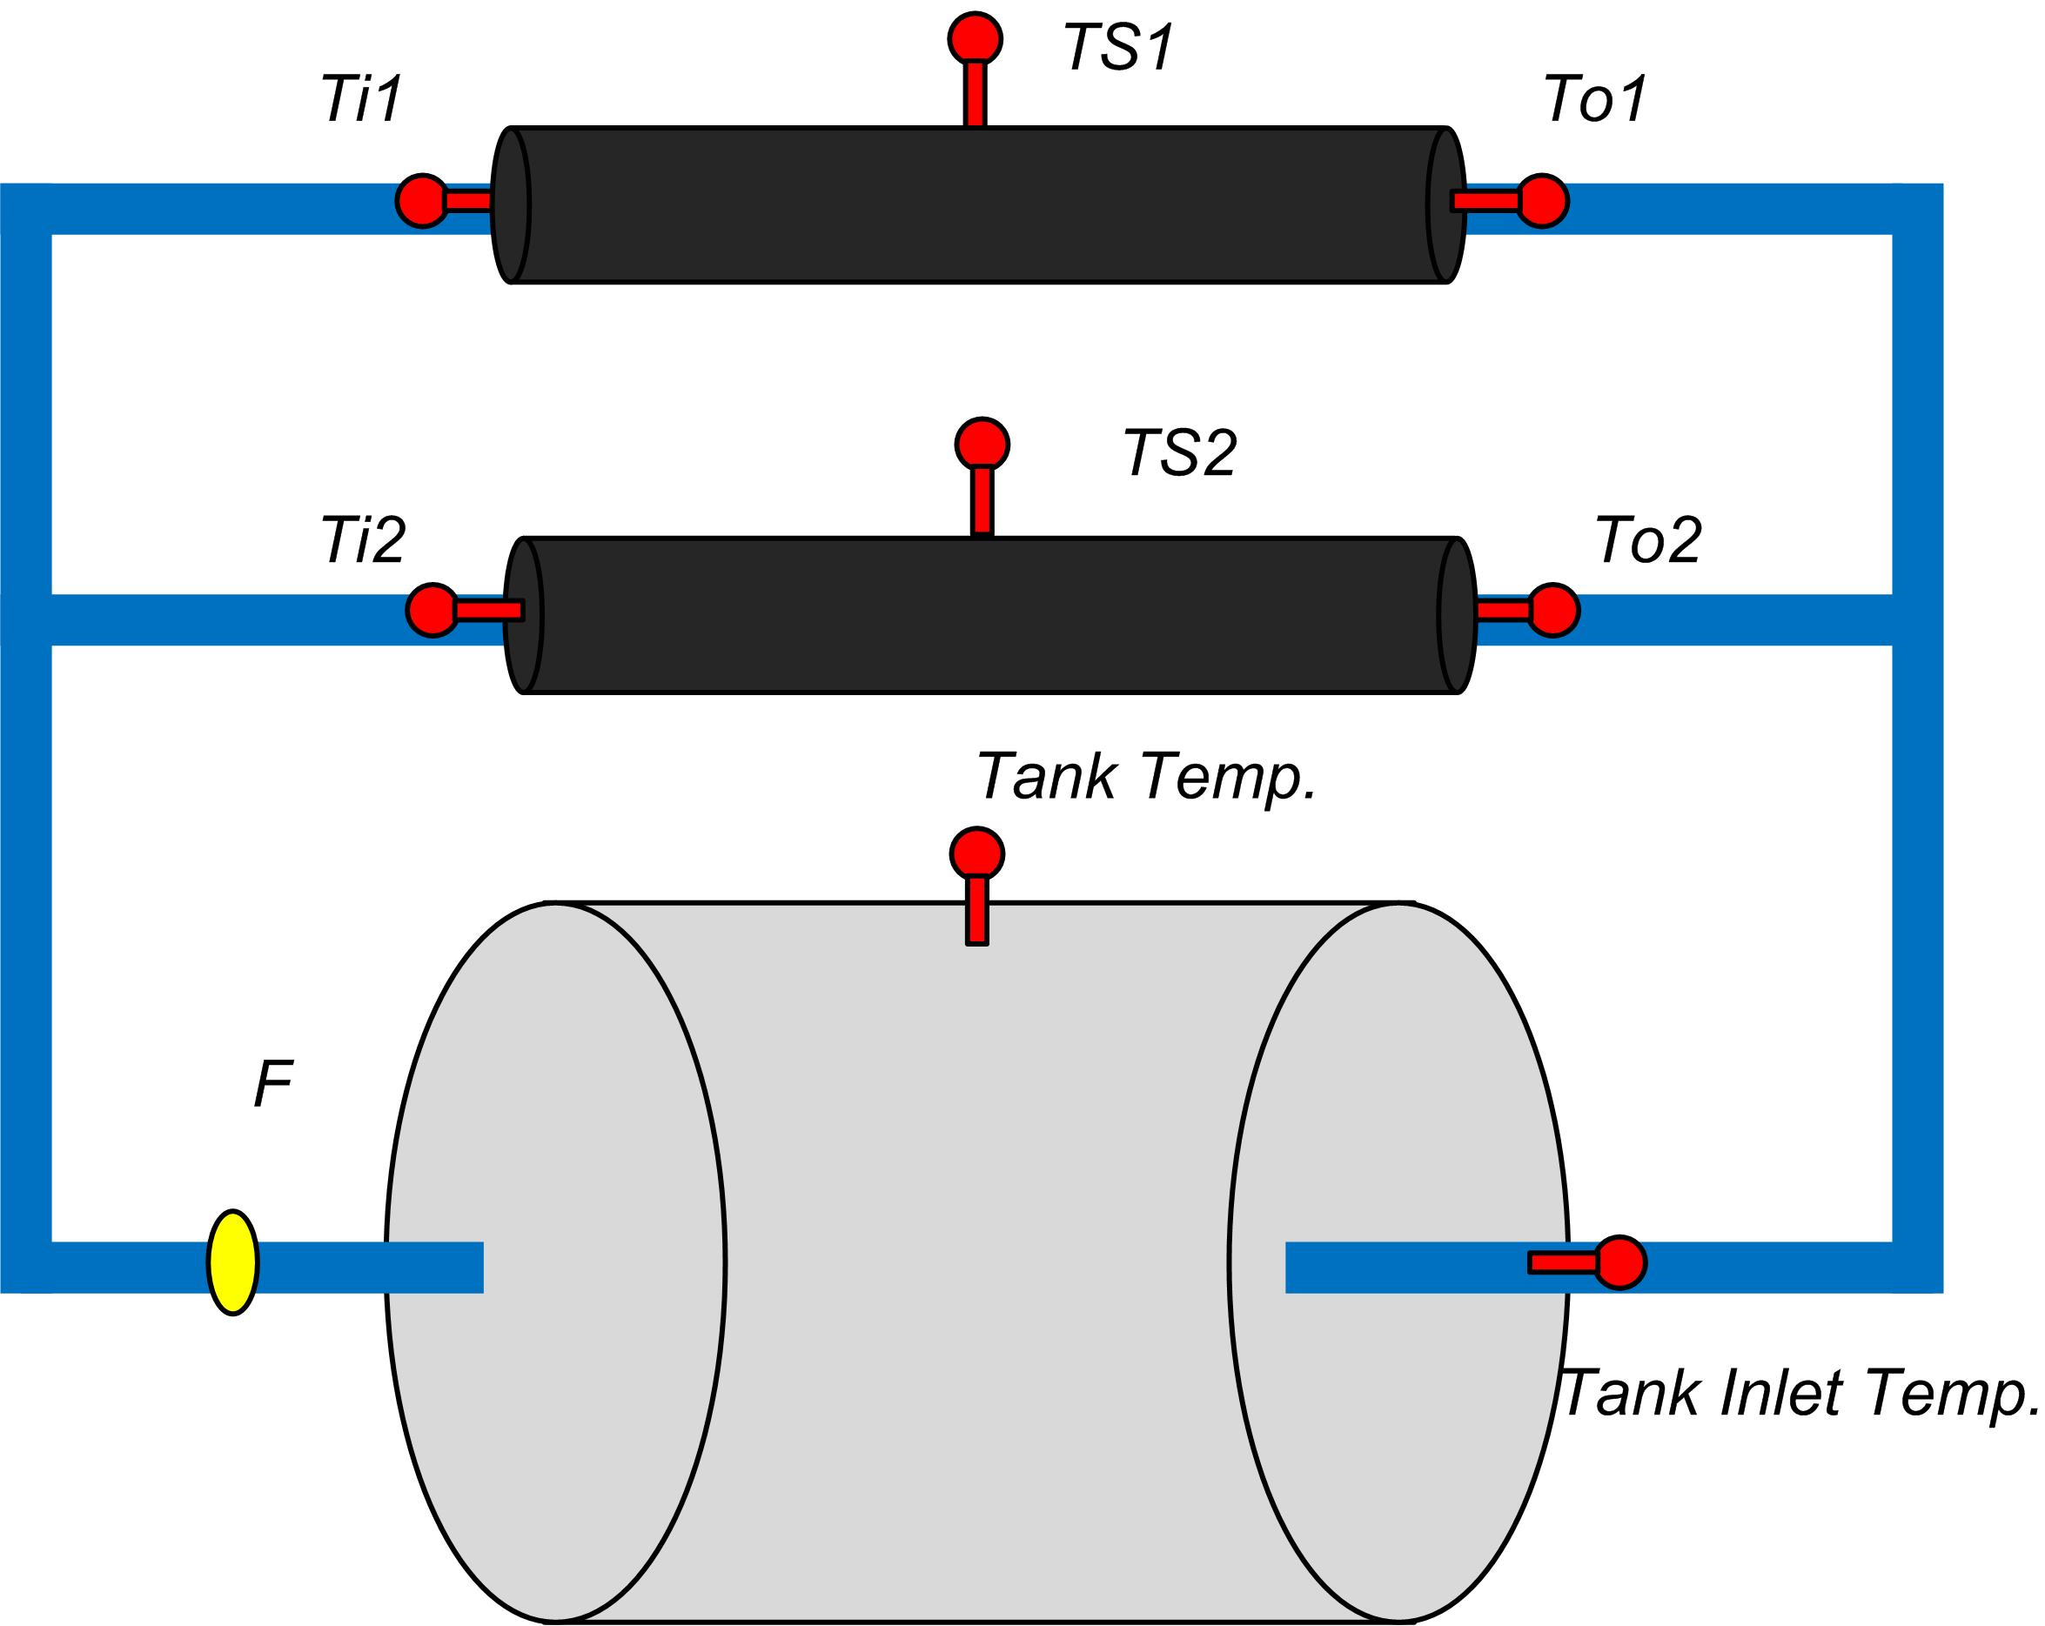



Where T3 is average temperature of Receiver Tube. As shown in Figure.

In case of Water as Heat Transfer Fuild

T3 = (Ts1 + T01+Ts2)/3

Where:

Ts1 = Surface Temperature of First Receiver Tube

T01 = outlet Temperature of First Receiver Tube

Ts2 = Surface Temperature of Second Receiver Tube

To = Outlet Temperature of Second Receiver Tube.

## Set B: Oil as working fluid

Tank insulation thickness = Pipe insulation thickness =

Supply Voltage =

Supply Current =

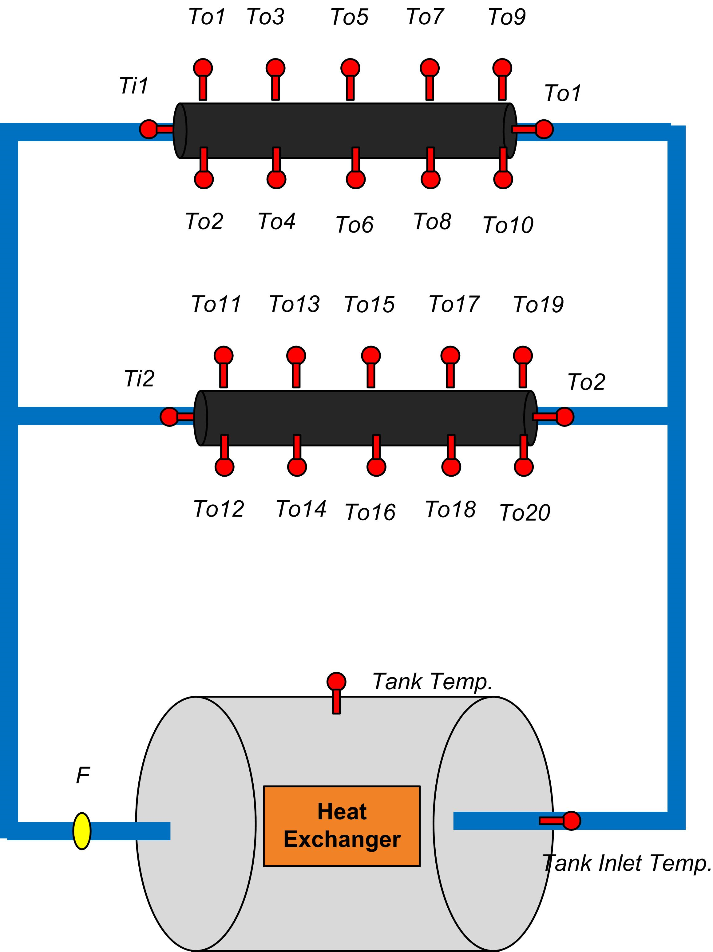

## Set B: Oil as working fluid





Where T3 is Average Receiver Tube Temperature

Ti = Receiver Tube Inlet Temperature of First Collector

To = Receiver Tube Outlet Temperature of 2nd Collector

T3 = (TS1 + To1 + Ts2)/3

Ts1 = (To1 + T02 + T03 +T04 + T05 + T06 + T07 + T08 + T09 + T010)/10

Ts2 = (To11 + T012 + T013 +To14 + To15 + T016 + T017 + T018 + T019 + T020)/10

Where:

Ts1 = Surface Temperature of First Receiver Tube

To1 = outlet Temperature of First Receiver Tube

Ts2 = Surface Temperature of Second Receiver Tube

Calculations

Follow the same calculations in the previous experiments and compare the results of both parabola in parallel mode

Nomenclature

